Date: 09-02-22

**1. Shared Preference**

**MainActivity.java**

package com.example.sharedpreferene;  
  
import androidx.appcompat.app.AppCompatActivity;  
  
import android.content.Intent;  
import android.content.SharedPreferences;  
import android.os.Bundle;  
import android.view.View;  
import android.widget.Button;  
import android.widget.EditText;  
  
public class MainActivity extends AppCompatActivity {  
  
 EditText e1;  
 Button b1;  
 SharedPreferences sp;  
  
 @Override  
 protected void onCreate(Bundle savedInstanceState) {  
 super.onCreate(savedInstanceState);  
 setContentView(R.layout.*activity_main*);  
 e1=findViewById(R.id.*name*);  
 b1=findViewById(R.id.*btn*);  
 sp=getSharedPreferences("share",*MODE_PRIVATE*); //session start  
  
 b1.setOnClickListener(new View.OnClickListener() {  
 @Override  
 public void onClick(View v) {  
 String val=e1.getText().toString();  
 sp.edit().putString("spkey", val).commit(); //commit-save  
  
 Intent i=new Intent(MainActivity.this, shared.class);  
 startActivity(i);  
 }  
 });  
 }  
}

**activity_main.xml**

<?xml version="1.0" encoding="utf-8"?>  
<androidx.constraintlayout.widget.ConstraintLayout xmlns:android="http://schemas.android.com/apk/res/android"  
 xmlns:app="http://schemas.android.com/apk/res-auto"  
 xmlns:tools="http://schemas.android.com/tools"  
 android:layout_width="match_parent"  
 android:layout_height="match_parent"  
 tools:context=".MainActivity">  
  
 <TextView  
 android:id="@+id/textView"  
 android:layout_width="207dp"  
 android:layout_height="45dp"  
 android:text="Enter your name"  
 app:layout_constraintBottom_toBottomOf="parent"  
 app:layout_constraintEnd_toEndOf="parent"  
 app:layout_constraintHorizontal_bias="0.498"  
 app:layout_constraintStart_toStartOf="parent"  
 app:layout_constraintTop_toTopOf="parent"  
 app:layout_constraintVertical_bias="0.32" />  
  
 <Button  
 android:id="@+id/btn"  
 android:layout_width="wrap_content"  
 android:layout_height="wrap_content"  
 android:text="Save"  
 app:layout_constraintBottom_toBottomOf="parent"  
 app:layout_constraintEnd_toEndOf="parent"  
 app:layout_constraintHorizontal_bias="0.498"  
 app:layout_constraintStart_toStartOf="parent"  
 app:layout_constraintTop_toTopOf="parent"  
 app:layout_constraintVertical_bias="0.553" />  
  
 <EditText  
 android:id="@+id/name"  
 android:layout_width="wrap_content"  
 android:layout_height="wrap_content"  
 android:ems="10"  
 android:inputType="textPersonName"  
 android:hint="Enter your name"  
 app:layout_constraintBottom_toBottomOf="parent"  
 app:layout_constraintEnd_toEndOf="parent"  
 app:layout_constraintHorizontal_bias="0.497"  
 app:layout_constraintStart_toStartOf="parent"  
 app:layout_constraintTop_toTopOf="parent"  
 app:layout_constraintVertical_bias="0.415" />  
</androidx.constraintlayout.widget.ConstraintLayout>

**shared.java**

package com.example.sharedpreferene;  
  
import androidx.appcompat.app.AppCompatActivity;  
  
import android.content.SharedPreferences;  
import android.os.Bundle;  
import android.widget.TextView;  
  
public class shared extends AppCompatActivity {  
 SharedPreferences sp;  
 @Override  
 protected void onCreate(Bundle savedInstanceState) {  
 super.onCreate(savedInstanceState);  
 setContentView(R.layout.*activity_shared*);  
 sp=getSharedPreferences("share",*MODE_PRIVATE*);  
 TextView t=findViewById(R.id.*tv2*);  
 String skvalue=sp.getString("spkey", "no data found");  
 t.setText(skvalue);  
 }  
}

**activity_shared.xml**

<?xml version="1.0" encoding="utf-8"?>  
<androidx.constraintlayout.widget.ConstraintLayout xmlns:android="http://schemas.android.com/apk/res/android"  
 xmlns:app="http://schemas.android.com/apk/res-auto"  
 xmlns:tools="http://schemas.android.com/tools"  
 android:layout_width="match_parent"  
 android:layout_height="match_parent"  
 tools:context=".shared">  
  
 <TextView  
 android:id="@+id/tv2"  
 android:layout_width="153dp"  
 android:layout_height="43dp"  
 app:layout_constraintBottom_toBottomOf="parent"  
 app:layout_constraintEnd_toEndOf="parent"  
 app:layout_constraintHorizontal_bias="0.461"  
 app:layout_constraintStart_toStartOf="parent"  
 app:layout_constraintTop_toTopOf="parent"  
 app:layout_constraintVertical_bias="0.247" />  
  
</androidx.constraintlayout.widget.ConstraintLayout>

**Output**

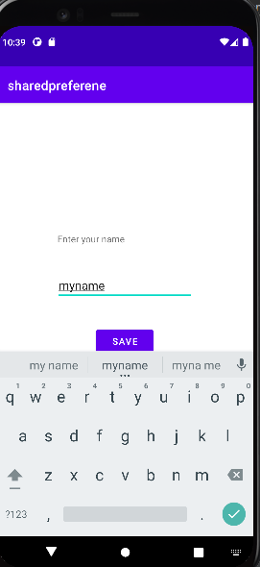 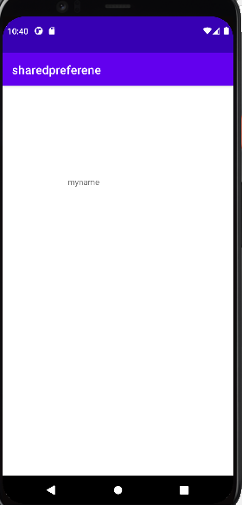

**Q. Develop an application that toggles image using frame layout**

**MainActivity.java**

package com.example.frameimagetoggle;  
  
import androidx.appcompat.app.AppCompatActivity;  
  
import android.os.Bundle;  
import android.view.View;  
import android.widget.ImageView;  
  
public class MainActivity extends AppCompatActivity {  
  
 @Override  
 protected void onCreate(Bundle savedInstanceState) {  
 super.onCreate(savedInstanceState);  
 setContentView(R.layout.*activity_main*);  
 ImageView i1=findViewById(R.id.*iv1*);  
 ImageView i2=findViewById(R.id.*iv2*);  
 i1.setOnClickListener(new View.OnClickListener() {  
 @Override  
 public void onClick(View v) {  
 i2.bringToFront();  
 }  
 });  
 i2.setOnClickListener(new View.OnClickListener() {  
 @Override  
 public void onClick(View v) {  
 i1.bringToFront();  
 }  
 });  
 }  
}

**activity_main.xml**

<?xml version="1.0" encoding="utf-8"?>  
<FrameLayout xmlns:android="http://schemas.android.com/apk/res/android"  
 xmlns:app="http://schemas.android.com/apk/res-auto"  
 xmlns:tools="http://schemas.android.com/tools"  
 android:layout_width="match_parent"  
 android:layout_height="match_parent"  
 tools:context=".MainActivity">  
  
 <ImageView  
 android:id="@+id/iv1"  
 android:layout_width="match_parent"  
 android:layout_height="wrap_content"  
 app:srcCompat="@drawable/img1" />  
  
 <ImageView  
 android:id="@+id/iv2"  
 android:layout_width="300dp"  
 android:layout_height="700dp"  
 app:srcCompat="@drawable/img2" />  
</FrameLayout>

**Output**

 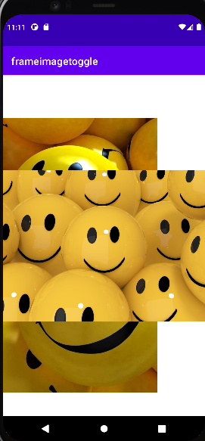

**Q. Fragments**

**MainActivity.java**

package com.example.fragments;  
  
import androidx.appcompat.app.AppCompatActivity;  
import androidx.fragment.app.Fragment;  
import androidx.fragment.app.FragmentManager;  
import androidx.fragment.app.FragmentTransaction;  
  
import android.os.Bundle;  
import android.view.View;  
import android.widget.Button;  
  
public class MainActivity extends AppCompatActivity {  
 Button b1,b2;  
 @Override  
 protected void onCreate(Bundle savedInstanceState) {  
 super.onCreate(savedInstanceState);  
 setContentView(R.layout.*activity_main*);  
 b1=findViewById(R.id.*btn1*);  
 b2=findViewById(R.id.*btn2*);  
  
 b1.setOnClickListener(new View.OnClickListener() {  
 @Override  
 public void onClick(View v) {  
 replaceFragement(new Fragment1());  
 }  
 });  
 b2.setOnClickListener(new View.OnClickListener() {  
 @Override  
 public void onClick(View v) {  
 replaceFragement(new Fragment2());  
  
 }  
 });  
 }  
  
 private void replaceFragement(Fragment fragment) {  
 FragmentManager fragmentManager=getSupportFragmentManager();  
 FragmentTransaction fragmentTransaction=fragmentManager.beginTransaction();  
 fragmentTransaction.replace(R.id.*framelayout*,fragment);  
 fragmentTransaction.commit();  
 }  
}

**activity_main.xml**

<?xml version="1.0" encoding="utf-8"?>  
<LinearLayout xmlns:android="http://schemas.android.com/apk/res/android"  
 xmlns:app="http://schemas.android.com/apk/res-auto"  
 xmlns:tools="http://schemas.android.com/tools"  
 android:layout_width="match_parent"  
 android:layout_height="match_parent"  
 android:orientation="vertical"  
 tools:context=".MainActivity">  
  
 <FrameLayout  
 android:layout_width="match_parent"  
 android:layout_height="0dp"  
 android:layout_weight="4"  
 android:id="@+id/framelayout"  
 android:background="@color/yellow"/>  
  
 <RelativeLayout  
 android:layout_width="match_parent"  
 android:layout_height="0dp"  
 android:layout_weight="1">  
  
 <Button  
 android:layout_width="100dp"  
 android:layout_height="50dp"  
 android:id="@+id/btn1"  
 android:text="fragment 1"  
 android:layout_alignParentBottom="true"  
 android:layout_marginStart="30dp"  
 android:layout_marginBottom="30dp"/>  
  
 <Button  
 android:layout_width="100dp"  
 android:layout_height="50dp"  
 android:id="@+id/btn2"  
 android:text="fragment 2"  
 android:layout_alignParentBottom="true"  
 android:layout_alignParentRight="true"  
 android:layout_marginRight="30dp"  
 android:layout_marginBottom="30dp"/>  
  
  
 </RelativeLayout>  
  
  
</LinearLayout>

**Fragment1.java**

package com.example.fragments;  
  
import android.os.Bundle;  
  
import androidx.fragment.app.Fragment;  
  
import android.view.LayoutInflater;  
import android.view.View;  
import android.view.ViewGroup;  
  
  
public class Fragment1 extends Fragment {  
  
  
 @Override  
 public View onCreateView(LayoutInflater inflater, ViewGroup container,  
 Bundle savedInstanceState) {  
 // Inflate the layout for this fragment  
 return inflater.inflate(R.layout.*fragment_1*, container, false);  
 }  
}

**fragment1.xml**

<?xml version="1.0" encoding="utf-8"?>  
<RelativeLayout xmlns:android="http://schemas.android.com/apk/res/android"  
 xmlns:tools="http://schemas.android.com/tools"  
 android:layout_width="match_parent"  
 android:layout_height="match_parent"  
 tools:context=".Fragment1">  
  
 <!-- *TODO: Update blank fragment layout* -->  
 <TextView  
 android:layout_width="wrap_content"  
 android:layout_height="wrap_content"  
 android:layout_centerInParent="true"  
 android:textSize="30dp"  
 android:text="fragment 1" />  
  
</RelativeLayout>

**Fragment2.java**

package com.example.fragments;  
  
import android.os.Bundle;  
  
import androidx.fragment.app.Fragment;  
  
import android.view.LayoutInflater;  
import android.view.View;  
import android.view.ViewGroup;  
  
  
public class Fragment2 extends Fragment {  
  
  
 @Override  
 public View onCreateView(LayoutInflater inflater, ViewGroup container,  
 Bundle savedInstanceState) {  
 // Inflate the layout for this fragment  
 return inflater.inflate(R.layout.*fragment_2*, container, false);  
 }  
}

**fragment2.xml**

<?xml version="1.0" encoding="utf-8"?>  
<RelativeLayout xmlns:android="http://schemas.android.com/apk/res/android"  
 xmlns:tools="http://schemas.android.com/tools"  
 android:layout_width="match_parent"  
 android:layout_height="match_parent"  
 android:background="@color/purple_200"  
 tools:context=".Fragment2">  
  
 <!-- *TODO: Update blank fragment layout* -->  
 <TextView  
 android:layout_width="wrap_content"  
 android:layout_height="wrap_content"  
 android:layout_centerInParent="true"  
 android:textSize="30dp"  
 android:text="fragment 2" />  
  
</RelativeLayout>

**Output**

